

**GAP ANALYSIS DOCUMENT (GAD) SIGN-OFF**

**Authorization Memorandum**

This form is to sign-off completion of the Requirement Phase for **CAMPUS MANAGEMENT SOFTWARE AT WORLD SKILL CENTER (WSC).**

World Skill Centre (WSC) acknowledges receipt of the deliverables as part of the Requirement Phase through the submission of this document.

|  |  |
| --- | --- |
| **MODULE NAME** | **Procurement & Inventory Management module** |

| **VERSION HISTORY** | | | |
| --- | --- | --- | --- |
| **Version** | **Author** | **Date** | **Changes** |
|  |  |  |  |
|  |  |  |  |

**WSC AUTHORITY NAME AND**  **SIGNATURE**

**SOUL AUTHORITY NAME AND**  **SIGNATURE**

Pages 1 of 19





**GAP Analysis Document**

Of

**Procurement & Inventory Management module**

For Implementation of

**Campus Management Software**

at

**World Skill Center (WSC)**

****

**Sustainable Outreach And Universal**

**Leadership (SOUL) Limited**

**Contents**

[A. Introduction 3](#_Toc4018)

[B. Overview of the Document 3](#_Toc29929)

[C. Existing Requisition Process Flow 6](#_Toc28172)

[D. WSC Requisition Flowchart 6](#_Toc2941)

[E. Existing Procurement Flowchart 8](#_Toc20234)

[F. Masters & Reports 9](#_Toc19828)

[1. Items & Pricing 9](#_Toc24817)

[1.1 Item 9](#_Toc31866)

[1.2 Item Price 11](#_Toc24912)

[2. Supplier 11](#_Toc8234)

[2.1 Supplier Group 11](#_Toc8312)

[3. Buying 12](#_Toc6702)

[3.1 Material Request 12](#_Toc27035)

[3.2 Purchase Order 13](#_Toc88)

[4. Assets 15](#_Toc15622)

[4.1 Asset 15](#_Toc5242)

[5. Maintenance 16](#_Toc29974)

[5.1 Asset Maintenance 16](#_Toc12296)

# **Introduction**

The World Skill Center (WSC) is a premier advanced skill training institute established by the Government of Odisha, Skill Development and Technical Education Department, through the Odisha Skill Development Authority (OSDA). The WSC will impart advanced skill training in eight trades from engineering and service sectors. WSC caters primarily to induct the best talent from ITIs and Polytechnics and train them to become globally employable in emerging areas such as "Industry 4.0". WSC is housed in a state-of-the-art, 18-storey, air-conditioned building with nearly half a million square feet of space in the heart of capital city of Bhubaneswar.

With the Implementation of campus management software for WSC the goal is to streamline the operations and functions of the campus by integrating various processes, such as admissions, course registration, academic progress tracking, and financial management, HRMS, Procurement and Inventory management, etc into a unified system. The implementation also aims at providing a user-friendly interface for all stakeholders, making it easier for them to access the necessary information and complete their tasks with ease. The modules to be covered during the implementation of the software includes:

|  |  |
| --- | --- |
| Students Management Modules | Infrastructure Management |
| Academic System | Finance and Accounting System |
| Procurement & Inventory Management | Training and Placement |
| Human Resources Management System | Application Integration |

# **Overview of the Document**

The Gap analysis document is a detailed report that provides an overview of the

gaps between the current state of the project and the desired state, and develop recommendations to close those gaps. Conducting a gap analysis can help us to improve our product and profitability by allowing us to pinpoint “gaps” present in our software. Once it’s complete, we will be able to better focus on our resources and energy on those identified areas in order to improve them.

This document covers all the gaps between the existing software and functional requirements provided by WSC SME’s for Procurement and Inventory management module.

**List of Screen**

The table below is list of screens present for Procurement and Inventory management screen. Yes in Change in Existing column means that there will be change for a existing screen in the Campus management software, while Is new screen means the screen is not present in the existing software and will be newly developed. This document contains list of changes in existing screens while requirements for new screens are covered in SRS document.

|  |  |  |  |
| --- | --- | --- | --- |
| **Sl no** | **Name of Screens** | **Changes in Existing** | **Is New Screen?** |
| 1 | [Item Group](" \l "_Toc29025 ) | No | No |
| 2 | [Item](" \l "_Toc6088 ) | Yes | No |
| 3 | [Item Price](" \l "_Toc2545 ) | Yes | No |
| 4 | [Price list](" \l "_Toc5514 ) | No | No |
| 5 | [Supplier](" \l "_Toc3783 ) | No | No |
| 6 | [Supplier Group](" \l "_Toc19213 ) | Yes | No |
| 7 | [Warehouse](" \l "_Toc28767 ) | No | No |
| 8 | [Unit of Measure (UOM)](" \l "_Toc21186 ) | No | No |
| 9 | [Purchase Taxes and Charges Template](" \l "_Toc11682 ) | No | No |
| 10 | [Tax Category](" \l "_Toc14100 ) | No | No |
| 11 | [Terms and Conditions Template](" \l "_Toc11259 ) | No | No |
| 12 | [Buying Setting](" \l "_Toc15168 ) | No | No |
| 13 | [Payment Terms Template](" \l "_Toc7794 ) | No | No |
| 14 | [Tax Withholding Category](" \l "_Toc28934 ) | No | No |
| 15 | [Quality Inspection Template](" \l "_Toc21363 ) | No | No |
| 16 | [Quality Inspection Parameter](" \l "_Toc30773 ) | No | No |
| 17 | [Material Request](" \l "_Toc16439 ) | Yes | No |
| 18 | [Request for Quotation](" \l "_Toc13488 ) | No | No |
| 19 | [Supplier Quotation](" \l "_Toc17467 ) | No | No |
| 20 | [Purchase Order](" \l "_Toc11241 ) | Yes | No |
| 21 | [Purchase Receipt](" \l "_Toc23137 ) | No | No |
| 22 | [Purchase Invoice](" \l "_Toc25890 ) | No | No |
| 23 | [Stock Entry](" \l "_Toc28242 ) | No | No |
| 24 | [Stock Setting](" \l "_Toc21148 ) | No | No |
| 25 | [Asset](" \l "_Toc3774 ) | Yes | No |
| 26 | [Location](" \l "_Toc28650 ) | No | No |
| 27 | [Asset Category](" \l "_Toc28107 ) | No | No |
| 28 | [Asset Movement](" \l "_Toc28266 ) | No | No |
| 29 | [Asset Maintenance Team](" \l "_Toc13943 ) | No | No |
| 30 | [Asset Maintenance](" \l "_Toc13351 ) | Yes | No |
| 31 | [Asset Maintenance Log](" \l "_Toc28554 ) | No | No |
| 32 | [Asset Repair](" \l "_Toc15289 ) | No | No |
| 33 | [Serial Number](" \l "_Toc17512 ) | No | No |
| 34 | [Batch](" \l "_Toc15526 ) | No | No |

# **WSC Requisition Process Flow Description**

|  |  |  |  |  |  |  |  |
| --- | --- | --- | --- | --- | --- | --- | --- |
| **SN** | **Type of Item** | **Board of Director** | **Chief Executive Officer** | **Principal** | **Deputy Principal** | **Director** | **Description** |
| **A** | **Purchase of Stocks/ Stores/ Stationeries** | | | | | |  |
| **Non-recurring** | | | | | | |  |
| A1 | Purchase of  Furniture/Computers/  Laptops/Printers/electronic items and other stock and store items | Nil | Full Power | Full Power | Nil | Nil | Chief Executive officer & Principal has access to Approve all requisition irrespective of price |
| **Recurring** | | | | | | |  |
| A2 | Printing & purchase of training/teaching /  learning materials / IEC  materials. | Nil | Full Power | Rs. 50000 to 100000 | Rs. 25000 to 50000 | upto Rs. 25000 | Director has permission to approve requisition upto 25000, Deputy Principal from 25000 to 50000, Principal from 50000 to 100000, while Chief Executive officer has access to approve upto any amount |
| A3 | Purchase of office  stationery &  computer stationery | Nil | Full Power | Rs. 50000 to 100000 | Rs. 25000 to 50000 | upto Rs. 25000 | Director has permission to approve requisition upto 25000, Deputy Principal from 25000 to 50000, Principal from 50000 to 100000, while Chief Executive officer has access to approve upto any amount |
| A4 | Monthly Recurring  payments like  Security/Gardening/Catering/Hostel/Transport | Nil | Nil | Full Power | Rs. 1 Lakh to Rs. 3 Lakh | upto Rs. 1 Lakh for each case | Principal has Authority to approve requisition upto any amount, Deputy Principal from 1 lakh to 3 lakh, Director upto 1 lakh only |
| **B** | **Construction Work** | | | | | |  |
| B1 | To convey administrative approval  of estimates of construction/repairs and interior designing. | Full Power | Nil | Nil | Nil | Nil | Only Board of Director has authority to approve requisition for any amount |
| **C** | **Hiring of Services** | | | | | |  |
| C1 | Engagement of firms for Consultancy/Auditor/Service Providers/Security/ and all other agency etc. | Full Power | Rs. 10 lakh to 1 crore | upto Rs. 10 Lakh | Nil | Nil | Board of Director has authority to approve requisition of any amount, Chief Executive Officer from 10 lakh to 1 crore, Principal upto 10 Lakh |
| C2 | Hiring of Individual  C2 Consultant/Legal  Adviser/  Expert/Research Person etc. | Nil | Full Power | upto Rs. 5 Lakh | Nil | Nil | Chief Executive Officer has authority to approve requisition of any amount, Principal upto 5 lakh only |
| **D** | **Sanction of Advance** | | | | | |  |
| D1 | Sanction of advances for  D1 tour/workshop/Meeting & Training etc. | Nil | Full Power | Full Power | Nil | Nil | Chief Executive officer and Principal has authority to approve requisition of any amount |
| **E** | **Approval for Sanction of Salaries and other Statutory Dues** | | | | | |  |
| **SN** | **Type of Power** | **Board of Director** | **Chief Executive Officer** | **Principal** | **Deputy Principal** | **Director** |  |
| E1 | Salaries of Staffs (For  Regular Staffs) | Nil | Full Power | Full Power | Full Power | Nil | Chief Executive Officer, Principal, Deputy Principalhas authority to approve requisition of any amount |
| E2 | Salaries of Staffs (For  Other Staffs) | Nil | Full Power | Full Power | Nil | Nil | Chief Executive Officer, Principalhas authority to approve requisition of any amount |
| E3 | To sanction other statutory  dues like TDS, NPS EPF etc | Nil | Full Power | Full Power | Full Power | Nil | Chief Executive Officer, Principal, Deputy Principalhas authority to approve requisition of any amount |
| **F** | **Sanction of Miscellaneous Expenditures** | | | | | |  |
| F1 | Telephone/ Internet/ Electricity& Water bill payment | Nil | Nil | Nil | Full Power | Full Power | Deputy Principal, Director has authority to approve requisition of any amount |
| F2 | AMC of Lifts/ HVAC/ Computers/ Copiers/ Fax/ AC/ Furniture etc. | Full Power | Rs. 5 lak to 50 lakh | Rs. 50000 to 500000 | RS. 20000 to 50000 | upto 20000 | Board of Director has authority to approve requisition of any amount, Chief Executive Officer from 5Lakh to 50 Lakh, Principal from 50000 to 5 Lakh, Deputy Principal from 20000 to 50000, Director upto 20000 |
| F3 | Sancxtion of expenditure on training/ workshop/ exposure/ mobilization/ campaign/ events etc. | Nil | Full Power | from 1 lakh to 5 lakh per batch | 50000 to 1lakh | upto 50000 | Chief Executive Officer has authority to approve requisition of any amount, Principal from 1 Lakh to 5 Lakh, Deputy Principal from 50000 Lakh to 1 Lakh, Director upto 50000 |
| F4 | Sanction of Payment towards hiring of monthly vehicles (All vehicles) | Nil | Full Power | Full Power | upto 1 lakh PM | upto 50000 PM | Chief Executive Officer, Principal has authority to approve requisition of any amount, Deputy Principal upto 1 Lakh Per month, Director upto 50000 Per month |
| F5 | Payment towards Advertisement/ Publication Expenses | Nil | Full Power | Full Power | upto 1 lakh PM | upto 50000 PM | Chief Executive Officer, Principal has authority to approve requisition of any amount, Deputy Principal upto 1 Lakh Per month, Director upto 50000 Per month |
| F6 | Sanction of contingent and miscellaneous expenses. | Nil | Full Power | Full Power | from 20000 to 50000 | upto 20000 | Chief Executive Officer, Principal has authority to approve requisition of any amount, Deputy Principal from 20000 upto 50000 , Director upto 20000 |
| F7 | other non-statutory dues related payment | Nil | Full Power | Full Power | upto 1 lakh | upto 50000 | Chief Executive Officer, Principal has authority to approve requisition of any amount, Deputy Principal from upto 1 Lakh, Director upto 50000 |
| F8 | Any other expenditure not categorized above | Nil | Full Power | Full Power | Nil | Nil | Chief Executive Officer, Principal has authority to approve requisition of any amount |

# **Masters & Reports**

## **Items & Pricing**

### **Item**

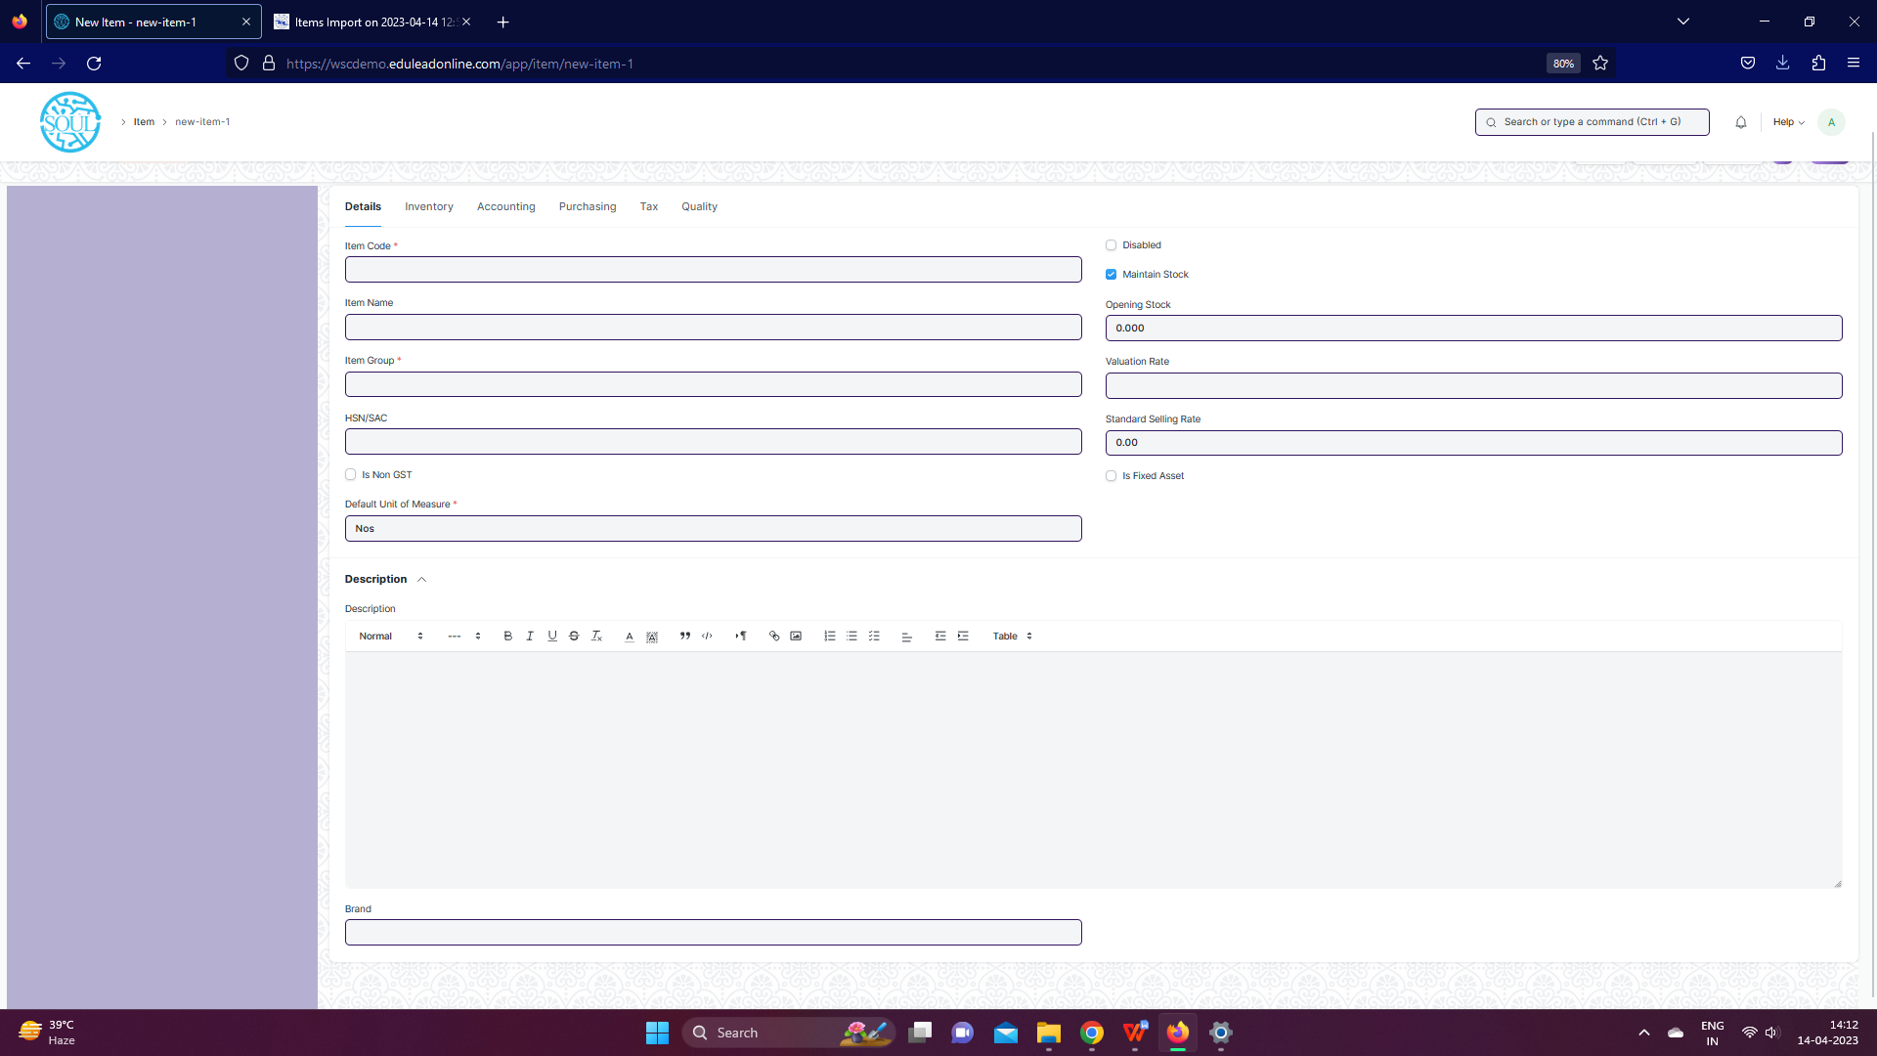

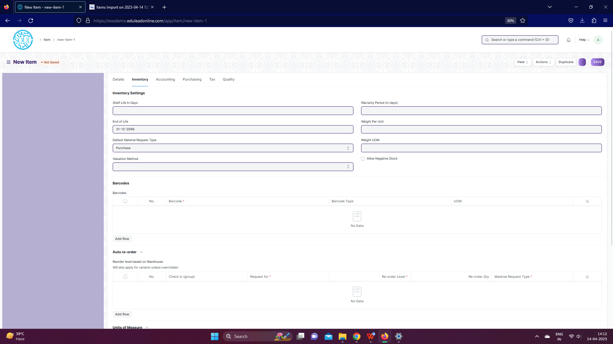

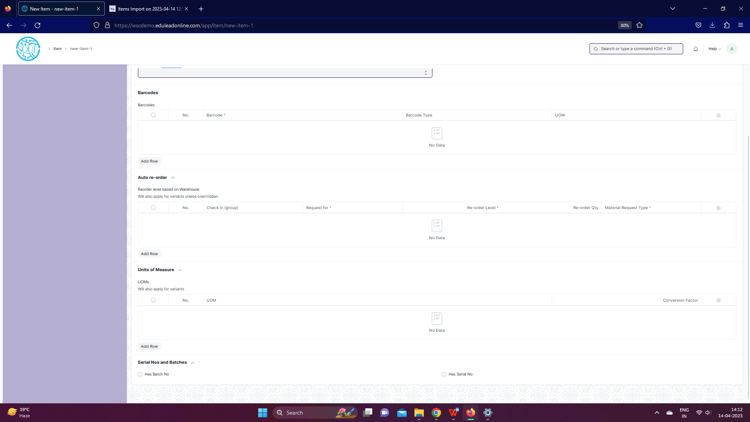

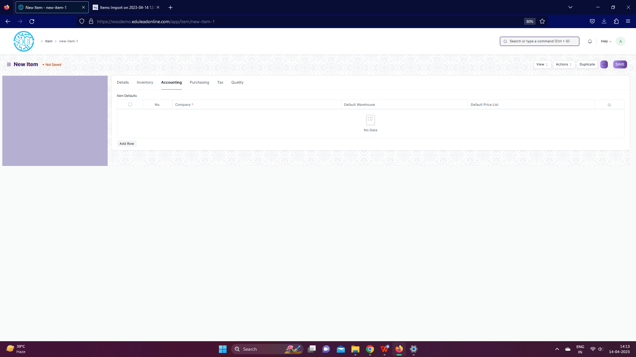

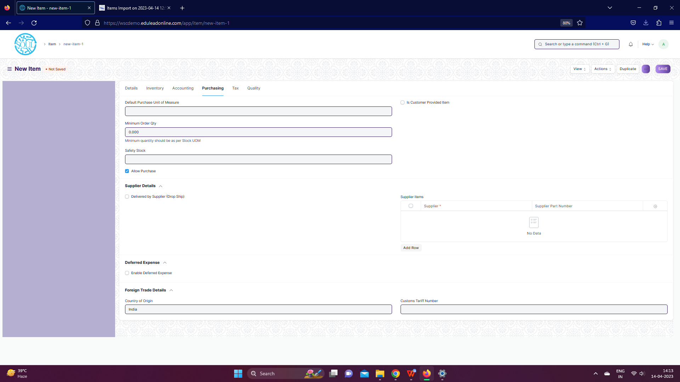

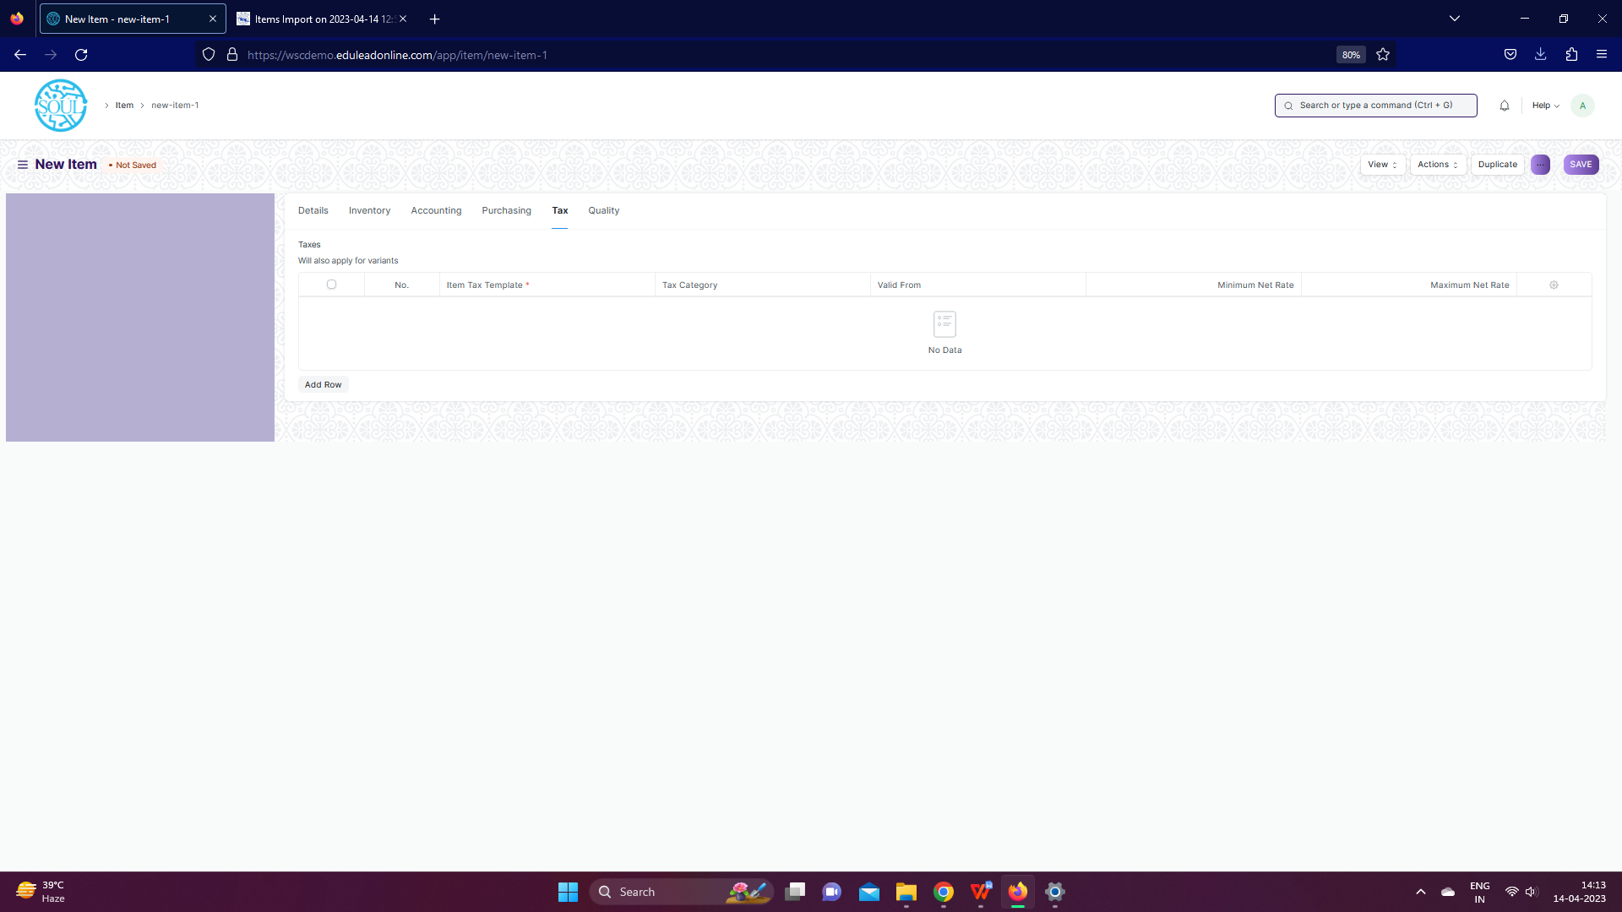

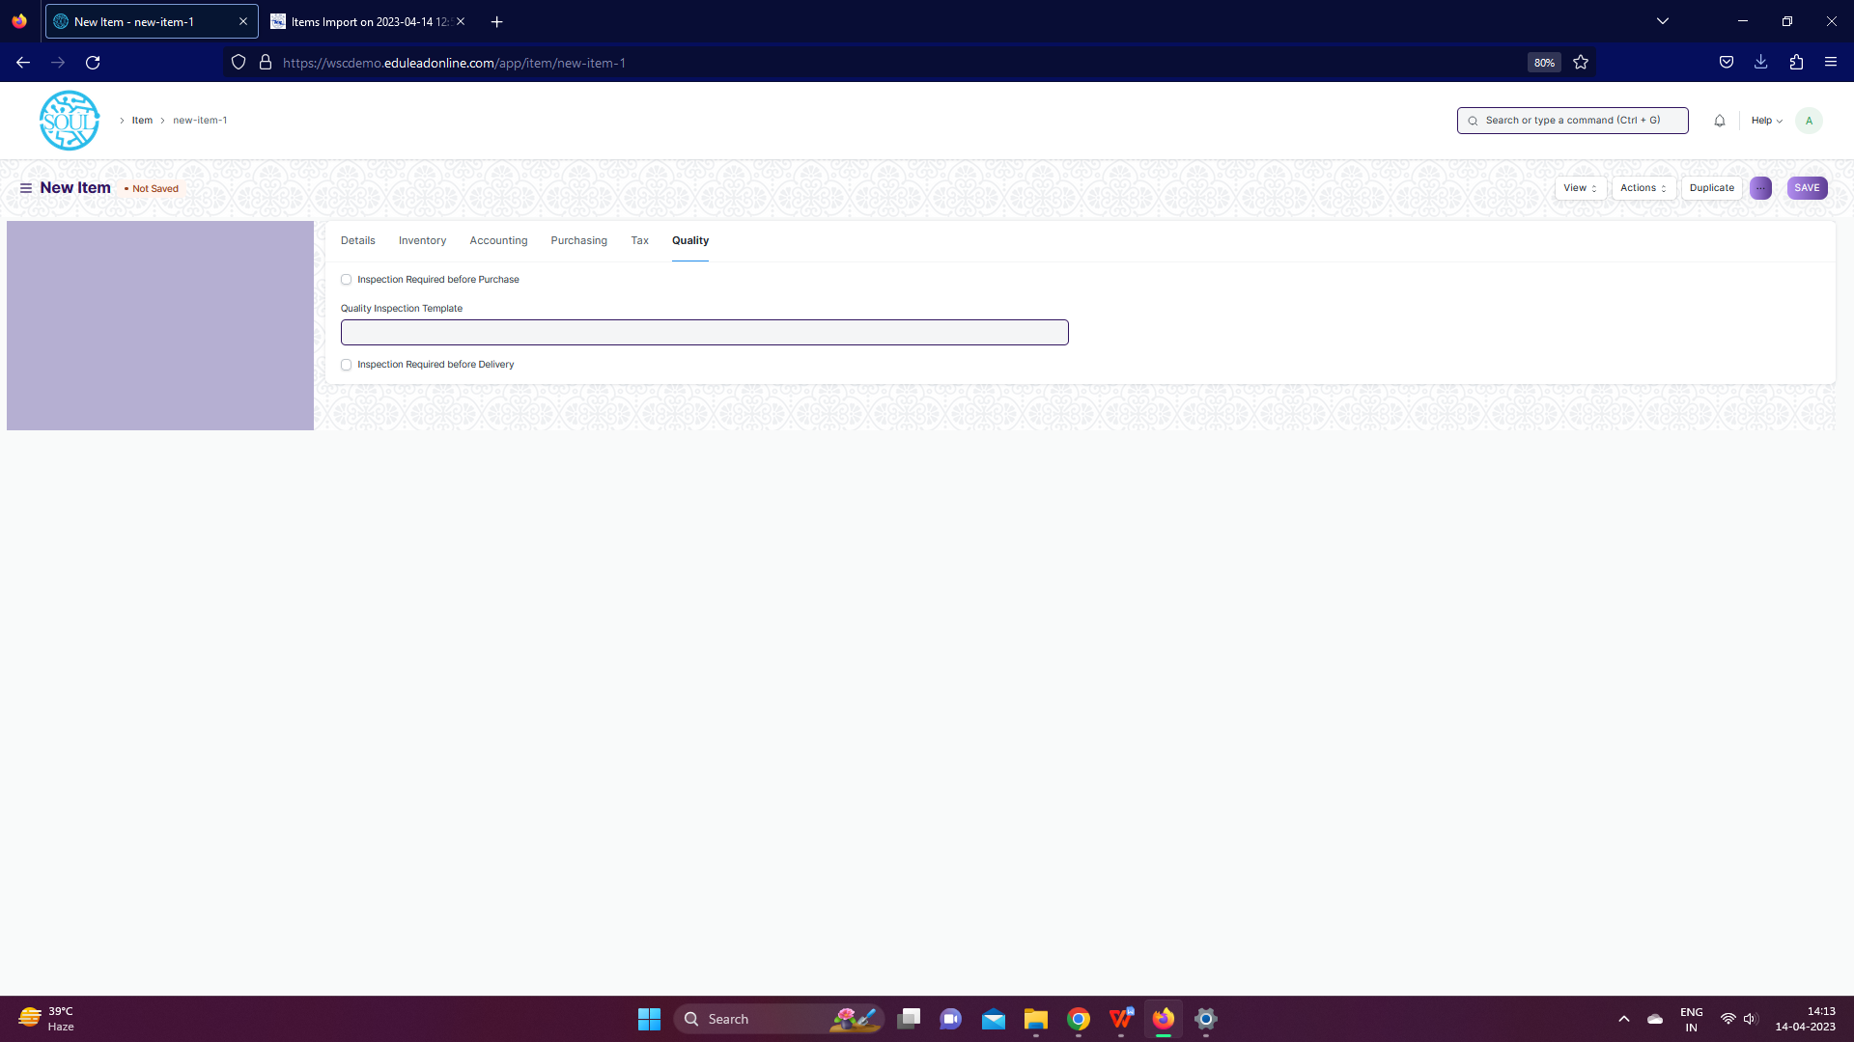

**Description of Changes:**

* In Item screen, Supplier tab, supplier child table will have attachment option and date of impalement
* Notification to be sent to Procurement department before 30 days of a product expiry date/ Warranty period to expire
* Notification to be sent to Procurement department if any Item has reached the defined the Safety stock level

### **Item Price**

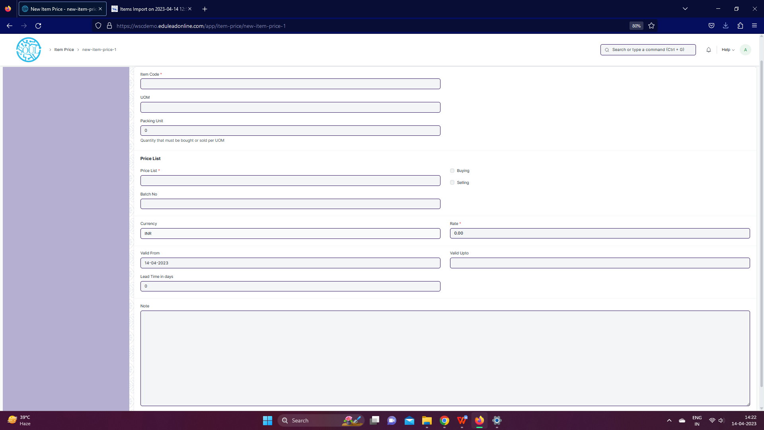

**Description of Changes:**

* Incase of changes in impaneled price, it will be approved by a set of authorities and be changed accordingly
* A report for change of impaneled price will be maintained

## **Supplier**

### **Supplier Group**

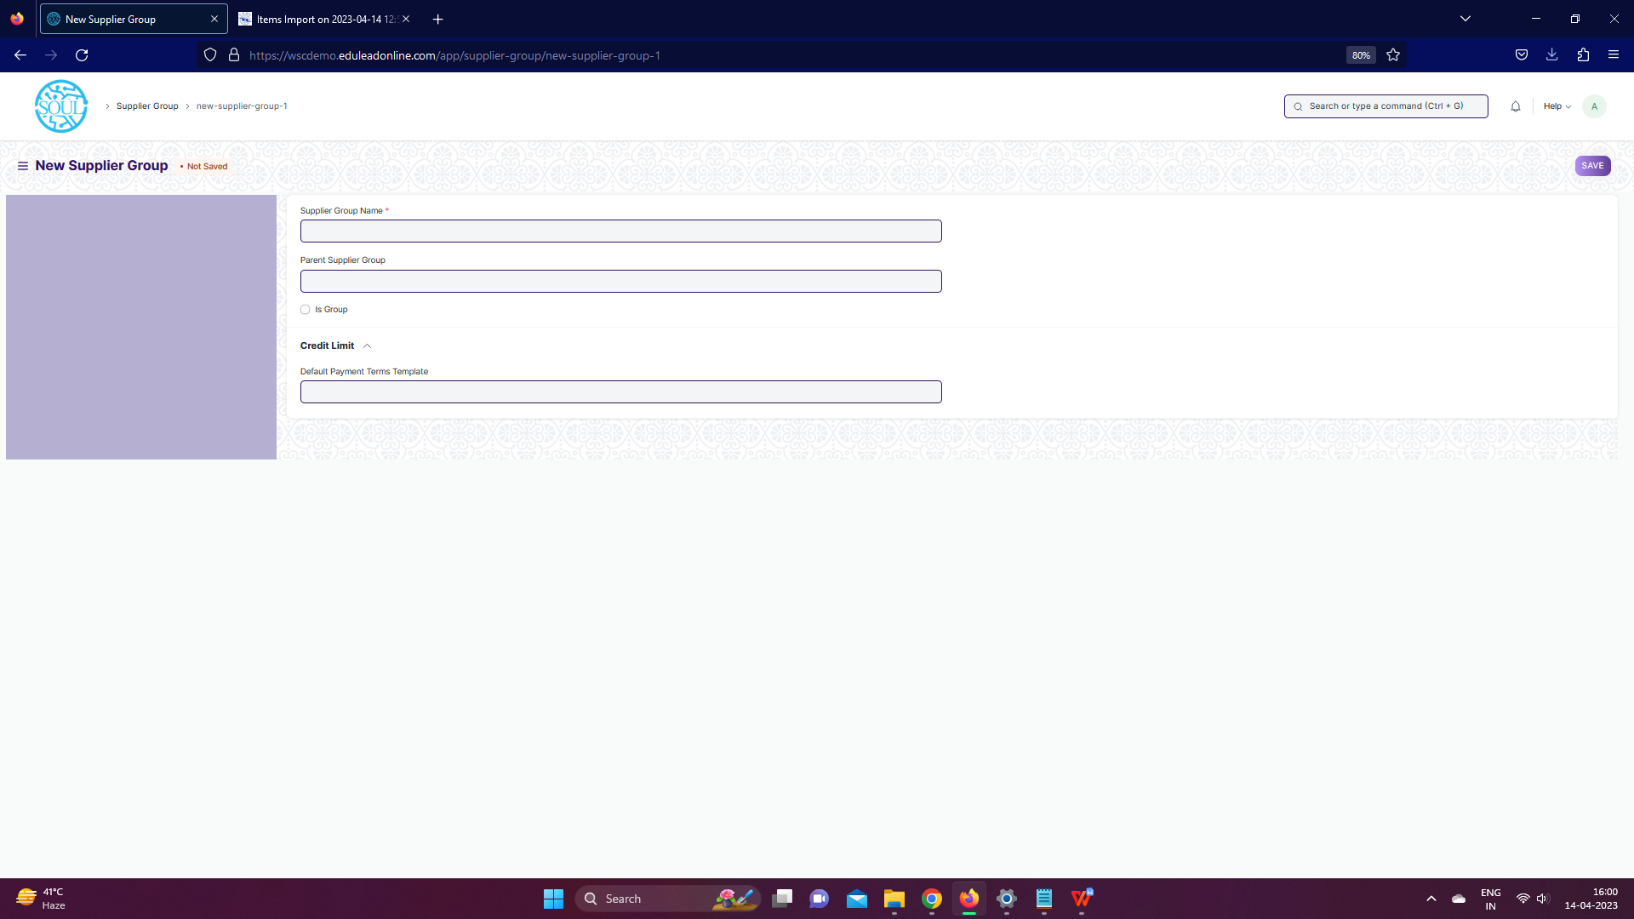

**Description of Changes:**

* Fields to be present in supplier form will be shared by WSC Procurement team, So that it will

customized in ERP form and the template could be shared by SOUL Team to WSC for sharing to their Suppliers which could be used to Import data

## **Settings**

### **Warehouse**

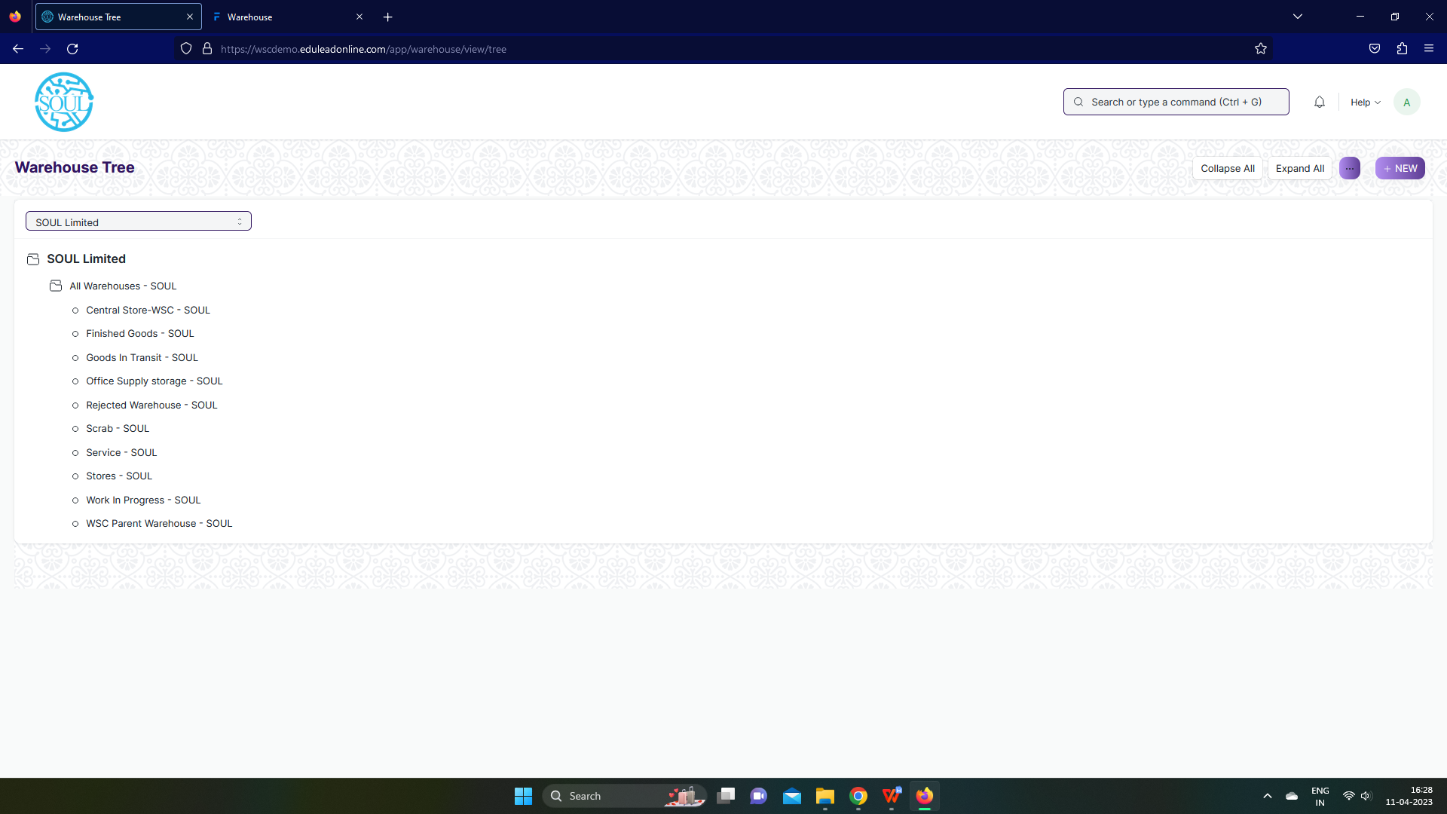

**Description of Changes:**

* Rename Warehouse Screen to Store

## **Buying**

### **Material Request**

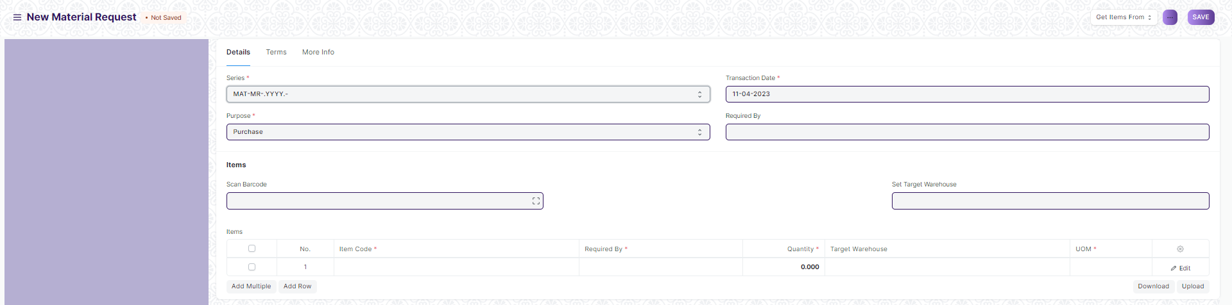

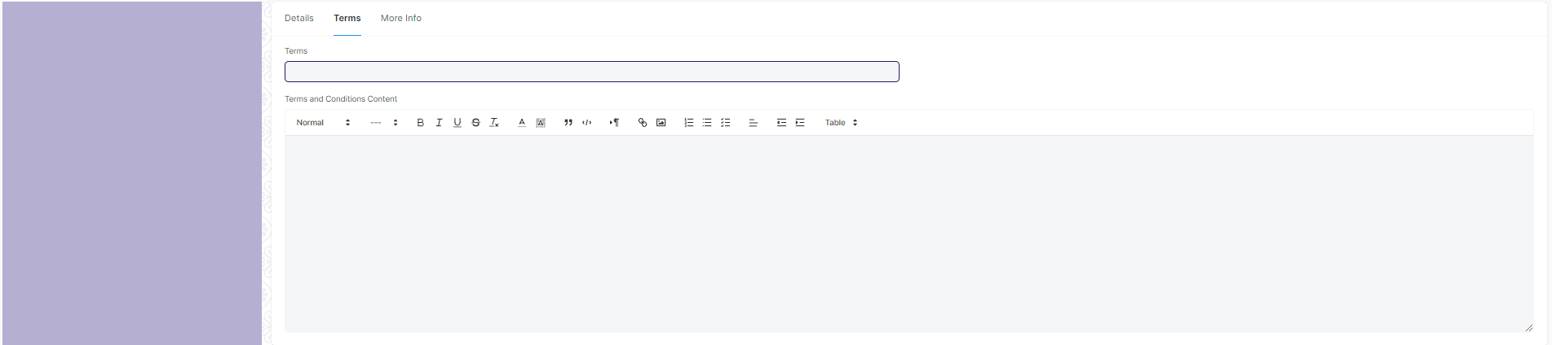





**Description of Changes:**

* Material request to be renamed to Purchase Requisition
* The status of the form will be changed to received once the item is received by the department who has raised its request
* Email should be sent based on workflow for requisition to necessary authority for approval of department-wise requisition
* Once approved by the department head, an email to be sent to the Central store every-time a new requisition is raised
* When material request is created for procurement no workflow will be triggered
* A receiving email from the receiving department will be sent to the central store upon accepting the required item
* Purchase / Material Requisition approval format attachment provision to be given in the system
* Course manager--> Dy Director--> Director--> Principal--> Procurement

### **Purchase Order**

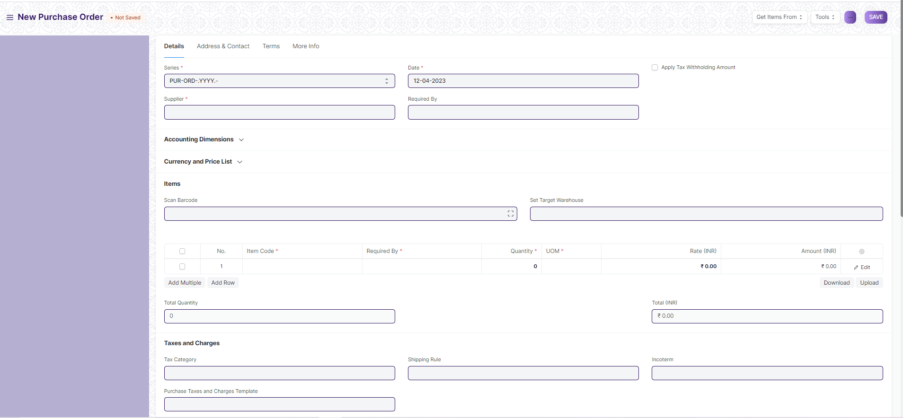

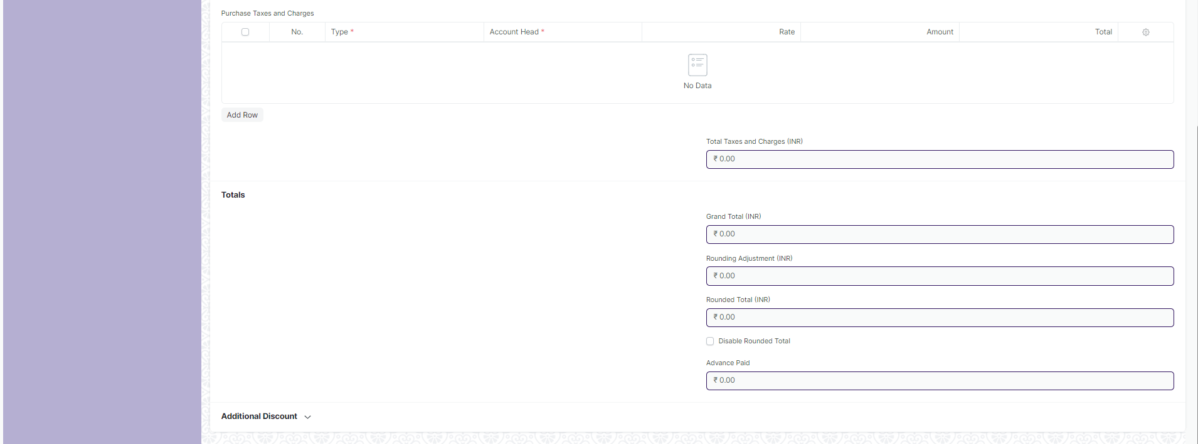

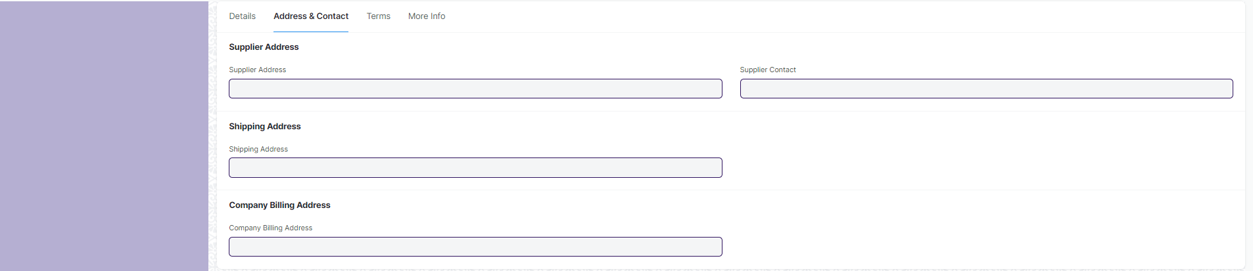

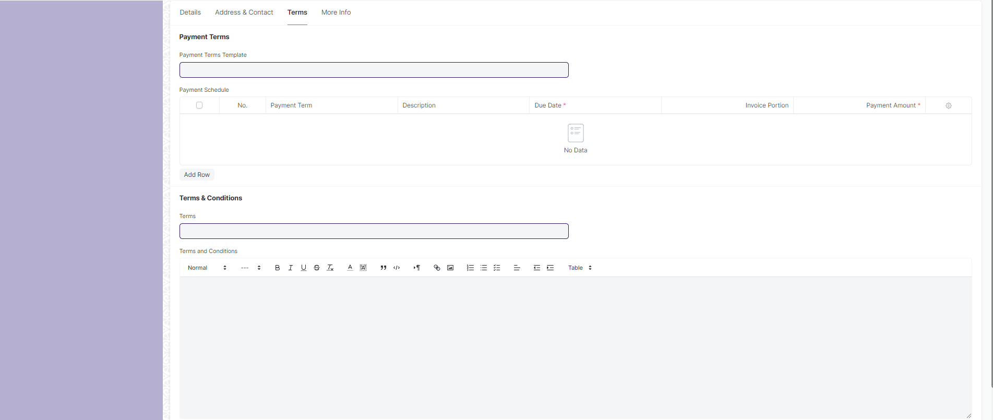

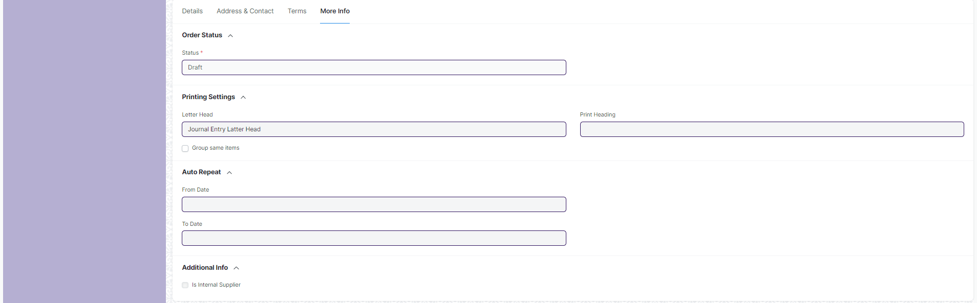

**Description of Changes:**

* Report for L1 vendor selection will be created for issuing PO based on L1 price
* Print format to be developed for PO
* Mail to be sent to supplier after 100% items are received for a PO

## **Assets**

* 1. **Asset**

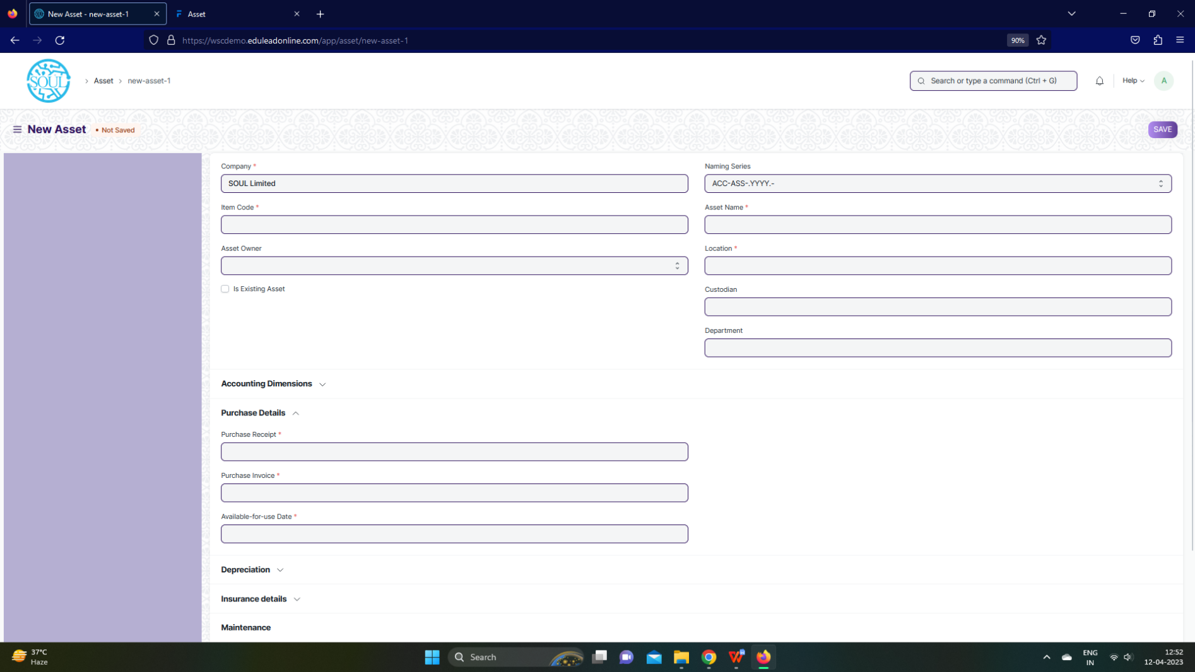

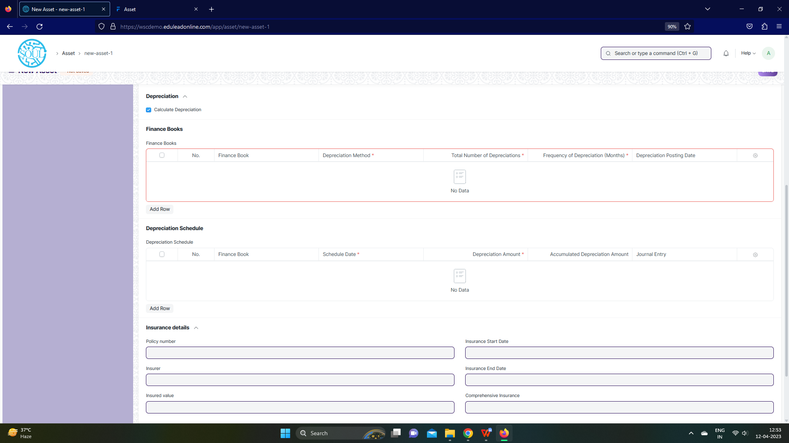

**Description of Changes:**

1. Asset report to be generated to differentiate between types of asset with remarks/comments
2. Stocks, Assets should be independent reports

## **Maintenance**

### **Asset Maintenance**

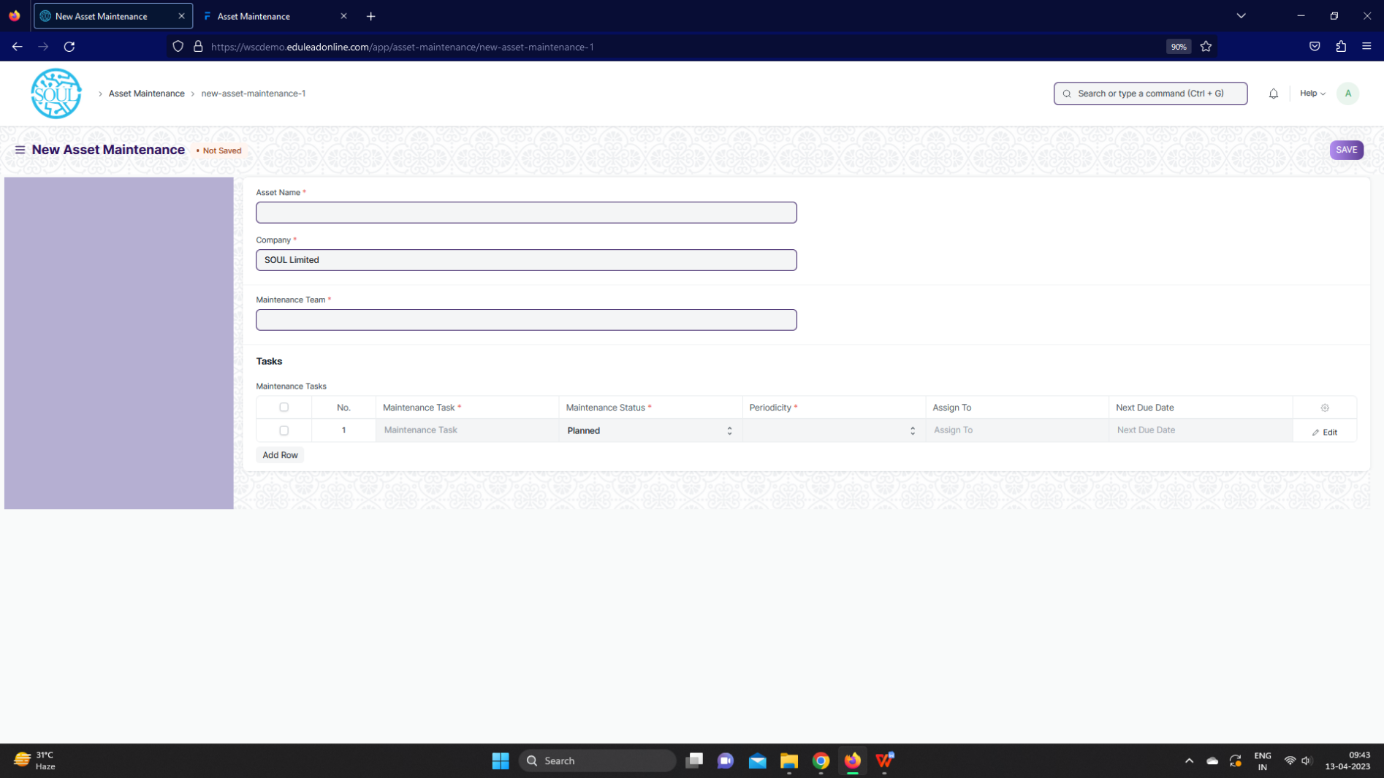

**Description of Changes:**

* Asset Maintenance, mail to be triggered when the maintenance tasks / maintenance

log is being recorded